PC2232 Physics for Electrical Engineers
Some exercise on Blackbody Radiation and Photoelectric Effect

- The temperature on the surface of the Sun is about 6000 K, according to Wien’s Law, what is the corresponding Wien wavelength?
  - 2.07 x 10 ⁶ m
  - 2.78 x 10 ^{–7} m
  - 4.83 x 10 ^{–7} m.
  - 6.14 x 10 ^{–7} m
  - 17.39 m

- Arrange the following electromagnetic wave in the order of decreasing energy: visible light, gamma ray (γ ray), X-ray, radio wave and ultra-violet (UV) ray.
  - γ ray, visible light , X-ray, radio wave and UV-ray
  - visible light, UV-ray, X -ray, radio wave and γ ray
  - visible light, γ ray, X -ray, radio wave and UV-ray
  - γ ray, X -ray, UV-ray, visible light and radio wave.
  - UV-ray, visible light, γ ray, X –ray and radio wave

- The following plot shows the blackbody radiation behavior of an object heated to a high temperature of 10000K. What is the corresponding Wien wavelength λ_{m}?
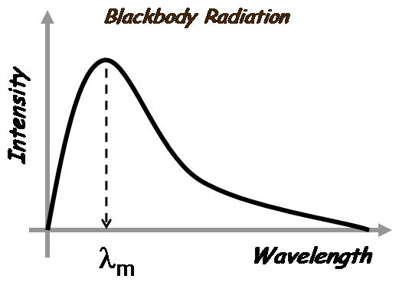
  - 144.9 nm
  - 289.8 nm.
  - 579.6 nm
  - 869.3 nm
  - 1159.1 nm

- Find the Wien’s wavelength of the radiation emitted by the tungsten filament of a lightbulb that operates at 2000 K.
  - 0.4 micron
  - 0.8 micron
  - 1.4 micron.
  - 1.6 micron
  - 2.0 micron

- Which of the following is not a true statement about the Blackbody radiation?
  - Energy density of the radiation increases with decreasing wavelength for all wavelengths.
  - It can be explained by Planck’s model
  - It explains the changes in color of a radiating body as its temperature changes
  - For a fixed wavelength, energy density of the radiation increases with temperature
  - None of the above

- The following plot shows the Blackbody Energy Density versus wavelength of two different cavities maintained at two different temperatures. What is the difference in the temperature between the two cavities? (Note that 2E-06 is the same as 2x10⁻⁶.)

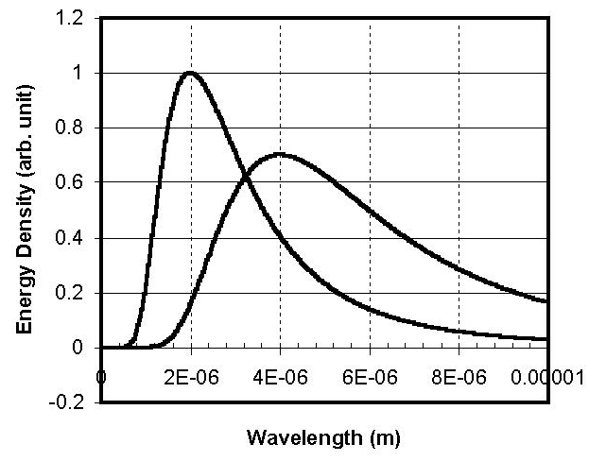

  - 1448.90 K
  - 1086.68 K
  - 724.45 K.
  - 362.22 K
  - 2x10⁻⁶ K

- Light of wavelength 4500 A is incident on a metal surface for which the maximum kinetic energy of the photoelectrons is 3.65 x 10^{–19}J. Calculate the work function of the metal.
  - 2.76 eV
  - 2.29 eV
  - 0.47 eV.
  - 4.76 eV
  - 1.00 eV

- In a certain metal, the work function of electrons is W = 2 x 10 ^{–19} J. Photons with a wavelength of λ = 4.0 x 10^{–7} m were used in an experiment to study the photoelectric effect. What is the magnitude of the stopping potential?
  - 1.84 V.
  - 1.54 V
  - 1.33 V
  - 1.20 V
  - 1.01 V

- Two different light sources were used in an experiment on photoelectric effect. The wavelength of the light used were 450 nm and 700 nm. It was found that the maximum kinetic energy of the electrons emitted from a metal surface differed by a factor of 2. Calculate the work function of the metal.
  - 0.88 x 10⁻¹⁹J
  - 1.10 x 10⁻¹⁹J
  - 1.26 x 10⁻¹⁹J.
  - 2.83 x 10⁻¹⁹J
  - 4.40 x 10⁻¹⁹J

- The wavelength of light incident on a metal surface is reduced from λ1 to λ2. What is the change in the stopping potential for λ1 = 295 nm and λ2 = 265 nm?

  - 0.119 V
  - 0.238 V
  - 0.476 V.
  - 0.714 V
  - 0.825 V

- The following plot shows the photocurrent versus applied potential obtained from three separate experiments concerning photoelectric effect. In these experiments, three light sources emitting light with wavelength λ₁, λ₂, and λ₃ respectively were used. The same metal surface was used throughout the experiments. Which of the following statements is not true?
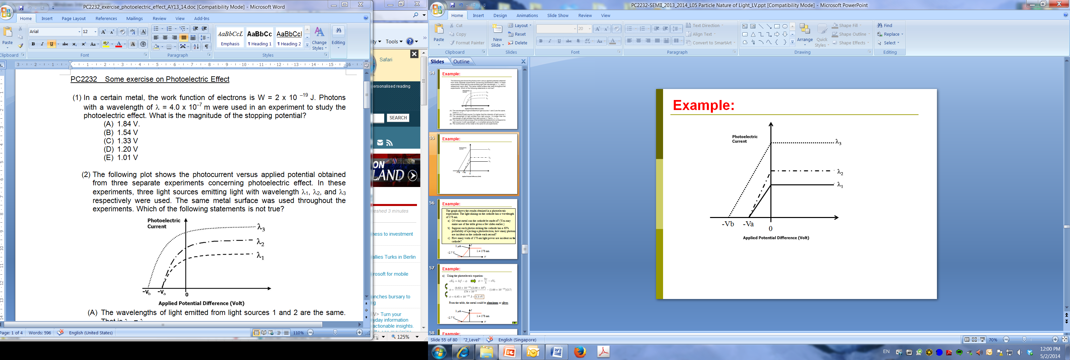
  - The wavelengths of light emitted from light sources 1 and 2 are the same. That is λ₁ = λ₂
  - The intensity of light source 2 is higher that the intensity of light source 1
  - The wavelength of light emitted from light source 1 is longer than the wavelength of light emitted from light source 3. That is, λ₁ > λ₃
  - The maximum kinetic energy of the emitted photoelectrons correspond to light source 3 (with wavelength λ₃) is smallest among the three.
  - The workfunction of the metal is the same for all experiments

- A student performed three separate experiments on photoelectric effect using three different light sources. The properties of the three light sources are summarized in the table below.

Light Source | Light Intensity | Wavelength of emitted light
I | I | λ
II | 2I | λ
III | 4I | 2λ/3

Which of the following figures would be the results of photocurrent versus applied potential obtained from these three separate experiments. The same metal surface was used throughout the experiments.

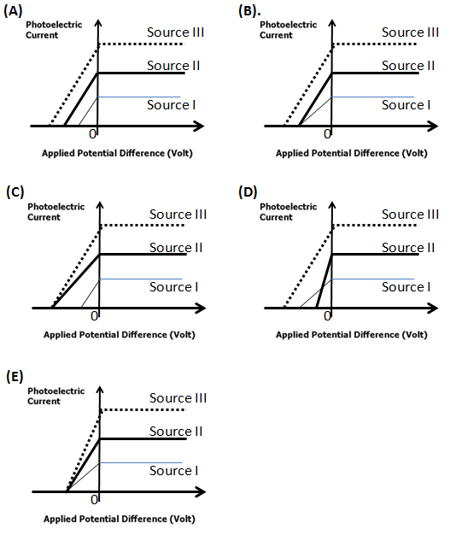

- Two different light sources were used in an experiment on photoelectric effect. The wavelength of the light used were 450 nm and 700 nm. It was found that the maximum kinetic energy of the electrons emitted from a metal surface differed by a factor of 2. Calculate the work function of the metal.
  - 0.88 x 10⁻¹⁹J
  - 1.10 x 10⁻¹⁹J
  - 1.26 x 10⁻¹⁹J.
  - 2.83 x 10⁻¹⁹J
  - 4.40 x 10⁻¹⁹J

- The following plot shows the photocurrent versus applied potential obtained from an experiment concerning photoelectric effect. In this experiment, two light sources emitting light with wavelength λ₁, and λ₂ respectively were used. The same metal was used throughout the experiment. Given that λ₁ = 650 nm and λ₂ = 398 nm, determine the work function of the metal.
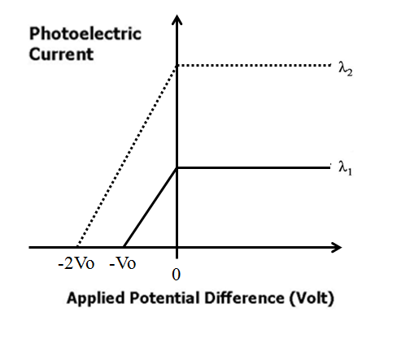
  - 0.00 eV
  - 0.70 eV.
  - 1.21 eV
  - 2.01 eV
  - 3.12 eV

- A student studying the photoelectric effect from two different metals. Using the same light source, the student found that the stopping potential for photoelectrons released from Metal A is 1.2 V larger than that for Metal B. Using light source where the wavelength of the light can be varied. The student also obtained the following plot of stopping potential versus frequency of incident photon for the two metals. Determine the work function for each metal.

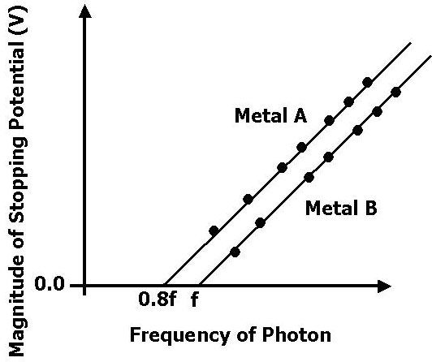

  - Workfunction of Metal A is 4.8 eV ; workfunction of Metal B is 6.0 eV.
  - Workfunction of Metal A is 6.0 eV ; workfunction of Metal B is 4.8 eV
  - Workfunction of Metal A is 2.4 eV ; workfunction of Metal B is 3.0 eV
  - Workfunction of Metal A is 3.0 eV ; workfunction of Metal B is 2.4 eV
  - Workfunction of Metal A is 5.8 eV ; workfunction of Metal B is 4.9 eV

- A student studying the photoelectric effect from two different metals by performing two separate experiments. In the first experiment, using a light source where the frequency of the light can be varied, the student obtained the following plot of stopping potential versus frequency of incident photon for the two metals. In the second experiment, using a light source emitting light with only one wavelength, the student found that the magnitude of stopping potential for photoelectrons released from Metal A is 1.6 V larger than that for Metal B. Determine the work function for each metal.

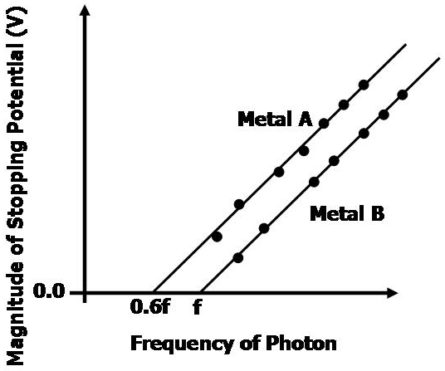

  - Workfunction of Metal A is 9.4 eV ; workfunction of Metal B is 7.8 eV
  - Workfunction of Metal A is 4.0 eV ; workfunction of Metal B is 2.4 eV
  - Workfunction of Metal A is 6.2 eV ; workfunction of Metal B is 4.6 eV
  - Workfunction of Metal A is 4.6 eV ; workfunction of Metal B is 6.2 eV
  - Workfunction of Metal A is 2.4 eV ; workfunction of Metal B is 4.0 eV.

